**CSA1054-SOFTWARE ENGINEERING**

**LAB EXPERIMENTS(day-2)**

**Name: K.Lakshmi**

**Register no:192211986**

**Experiment 11:** Make an Online Airline Reservation System. The activities of the Online Airline Reservation system are listed below user, admin, LOGIN, MANAGE CLASSES, MANAGE WAITING LIST, MANAGE HOLDS, MANAGE DEADLINES, LOGOUT, using this has a step-by-step process draw a CLASS diagram

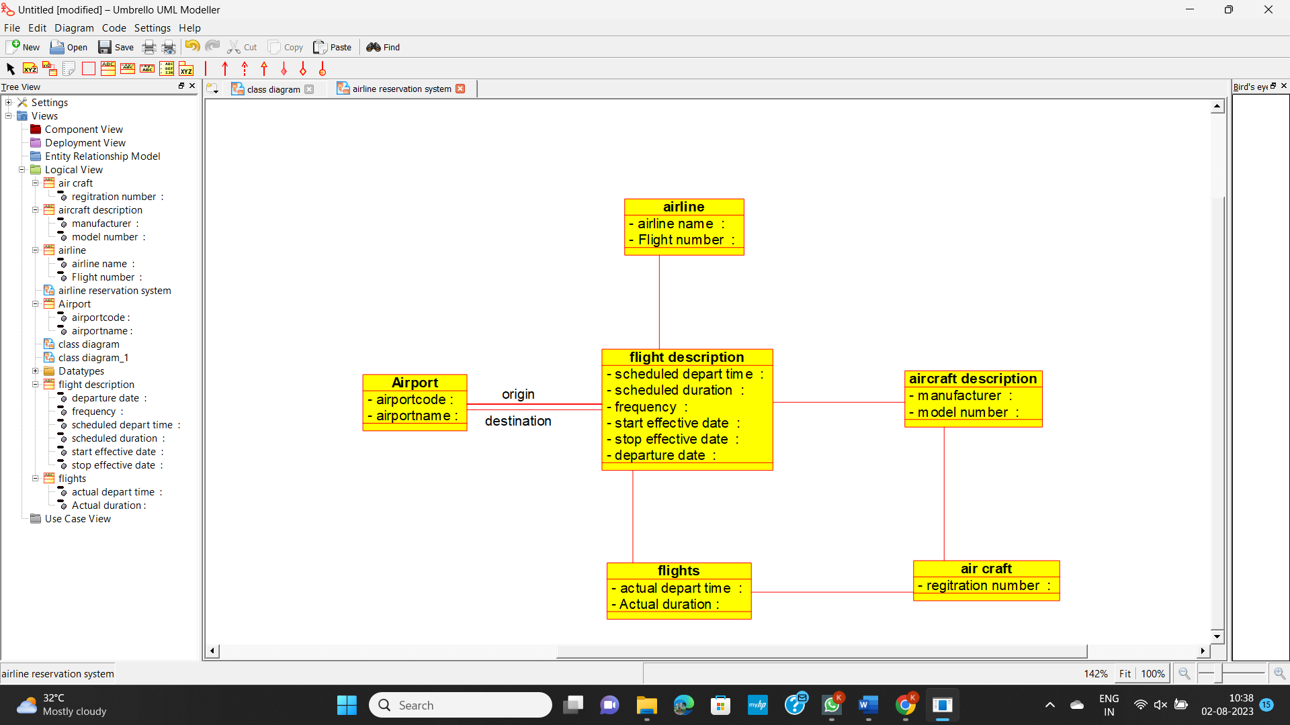

**Experiment 12:** Draw a Class diagram for Online Voting System using CASE tools. E Vote is an election system that facilitates voters to record their secure and secret ballot electronically. It has a friendly user interface and enables voters to cast their votes in a few simple steps. We ensure the authenticity of the voters and the votes cast by them along with non-traceability of the casted vote elaborate the whole process of e-voting.

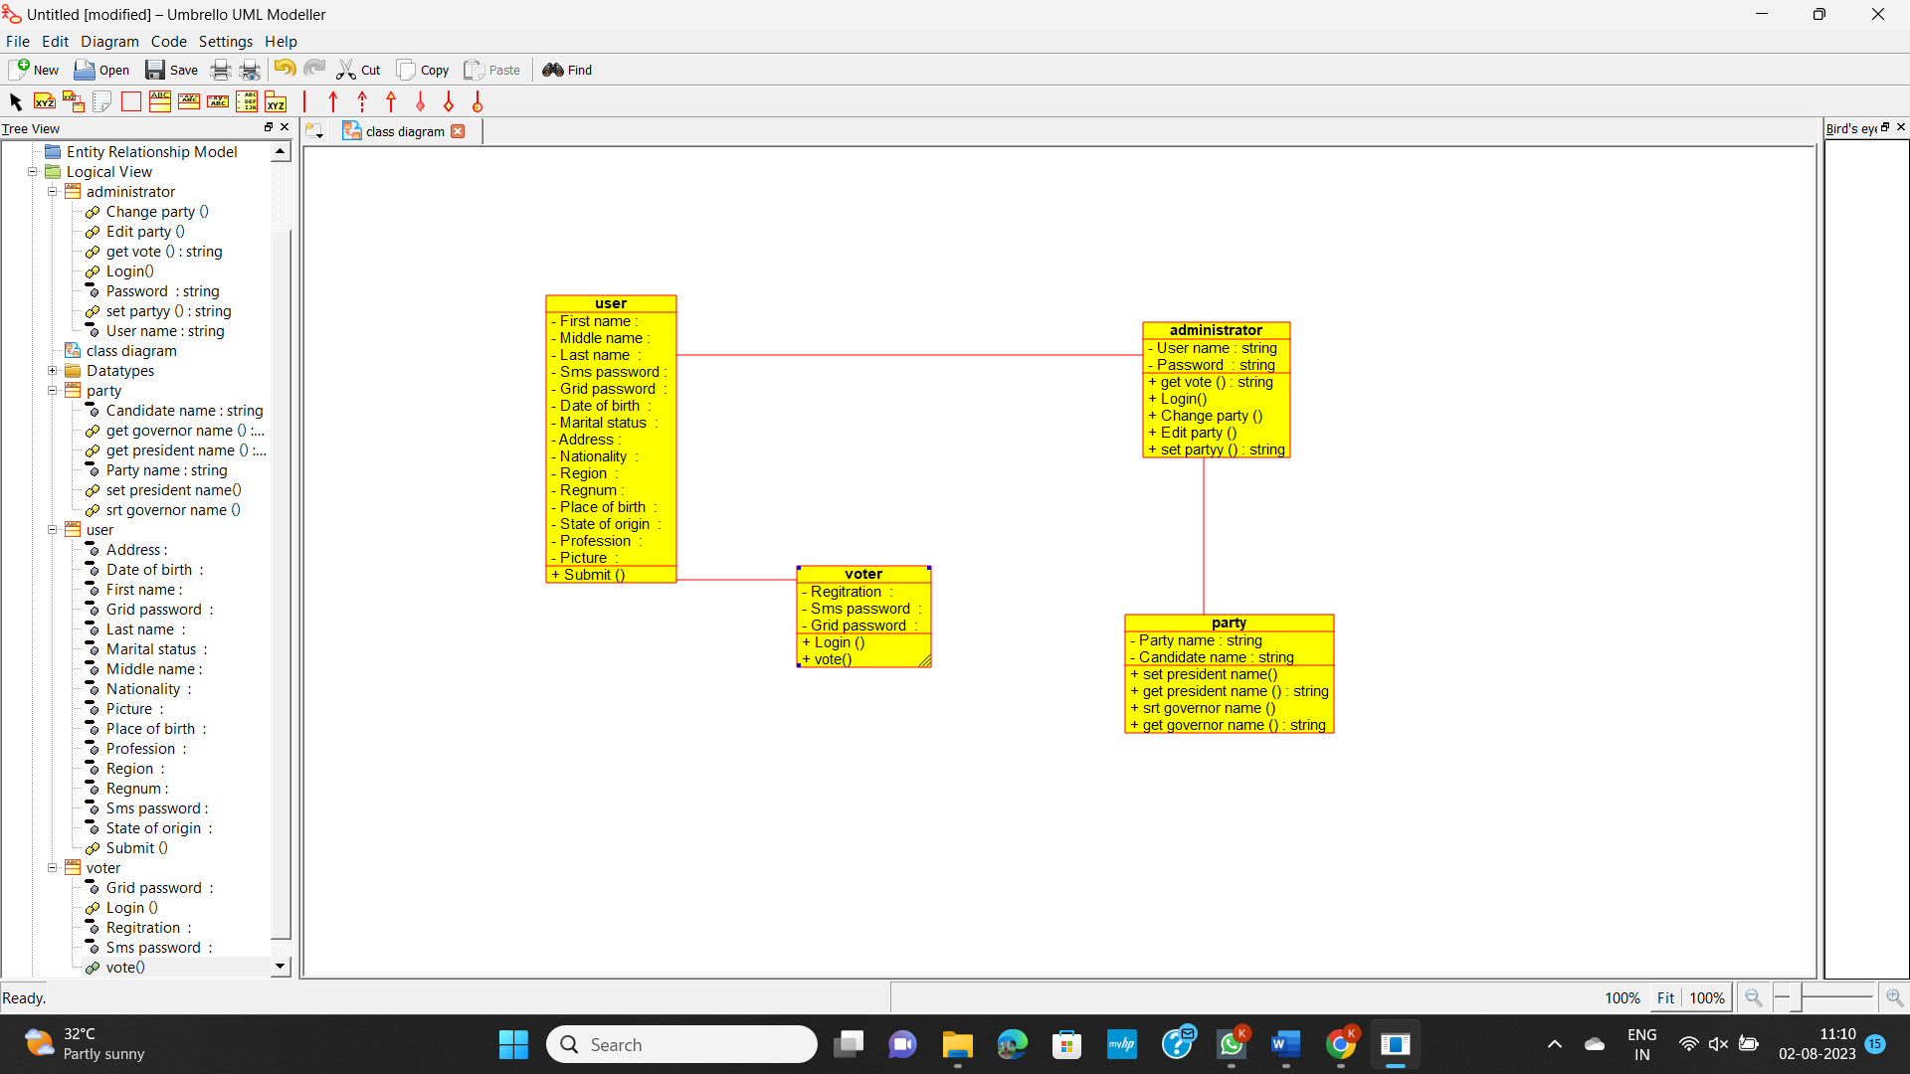

**Experiment 13:** Draw a Class diagram for Library Management System using CASE tools. Designing use case diagram for the library management system. User who registers himself as a new user initially is regarded as staff or student for the library system. Librarians have a key role in this system. Librarian adds the records in the library database about each student or user every time issuing the book or returning the book, or paying a fine. Design the class diagram for this

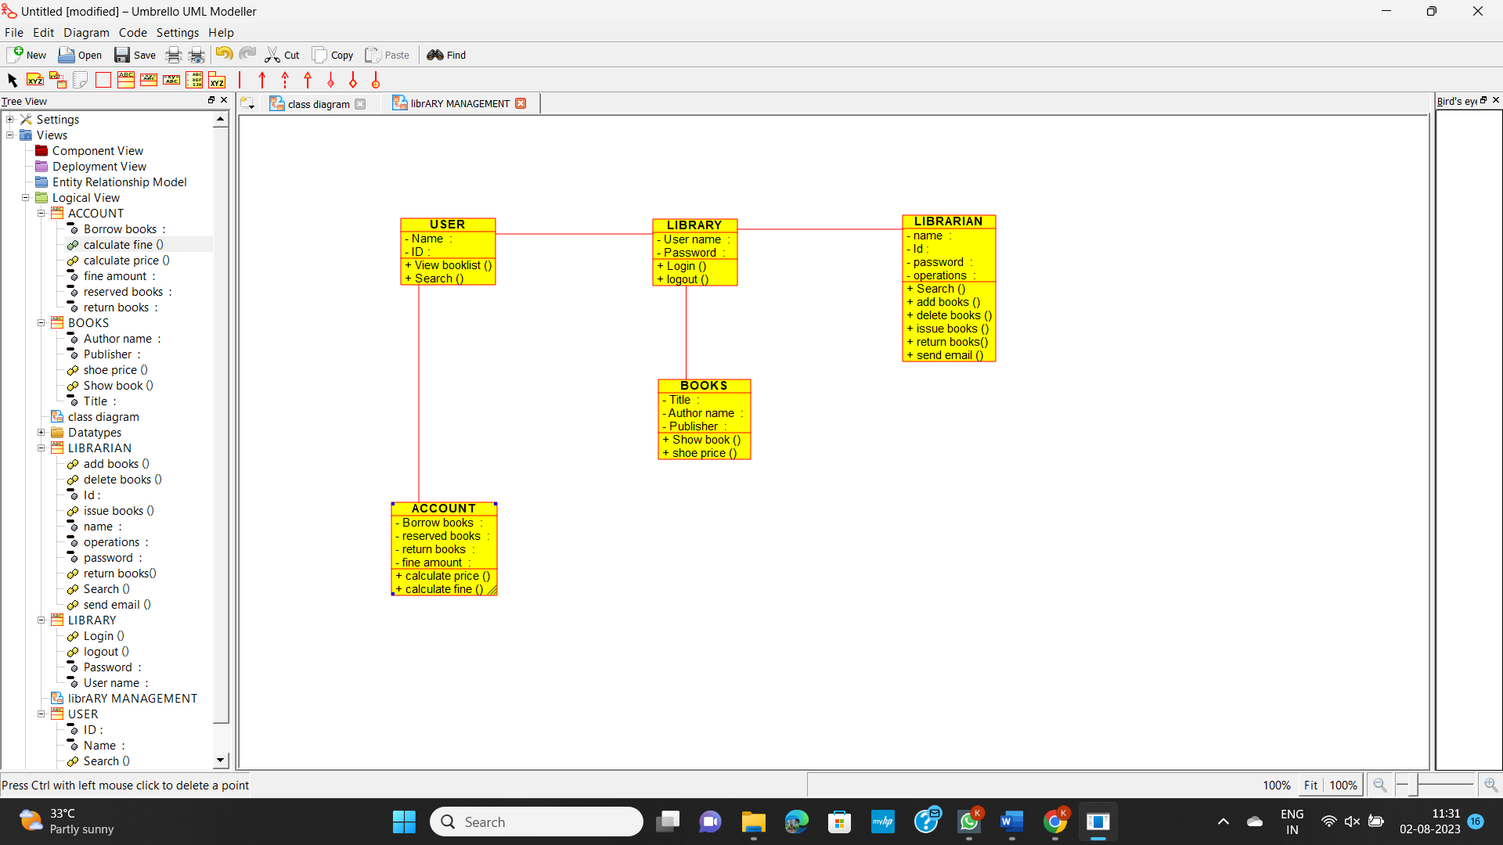

**Experiment 14:** Draw a Class diagram for an e-library online public access catalogue. The activities of the system are listed below. Patrons of a library can search the library catalogue online to locate various resources - books, periodicals, audio and visual materials, or other items under the control of the library. Patrons may reserve or renew items, provide feedback, and manage their account.

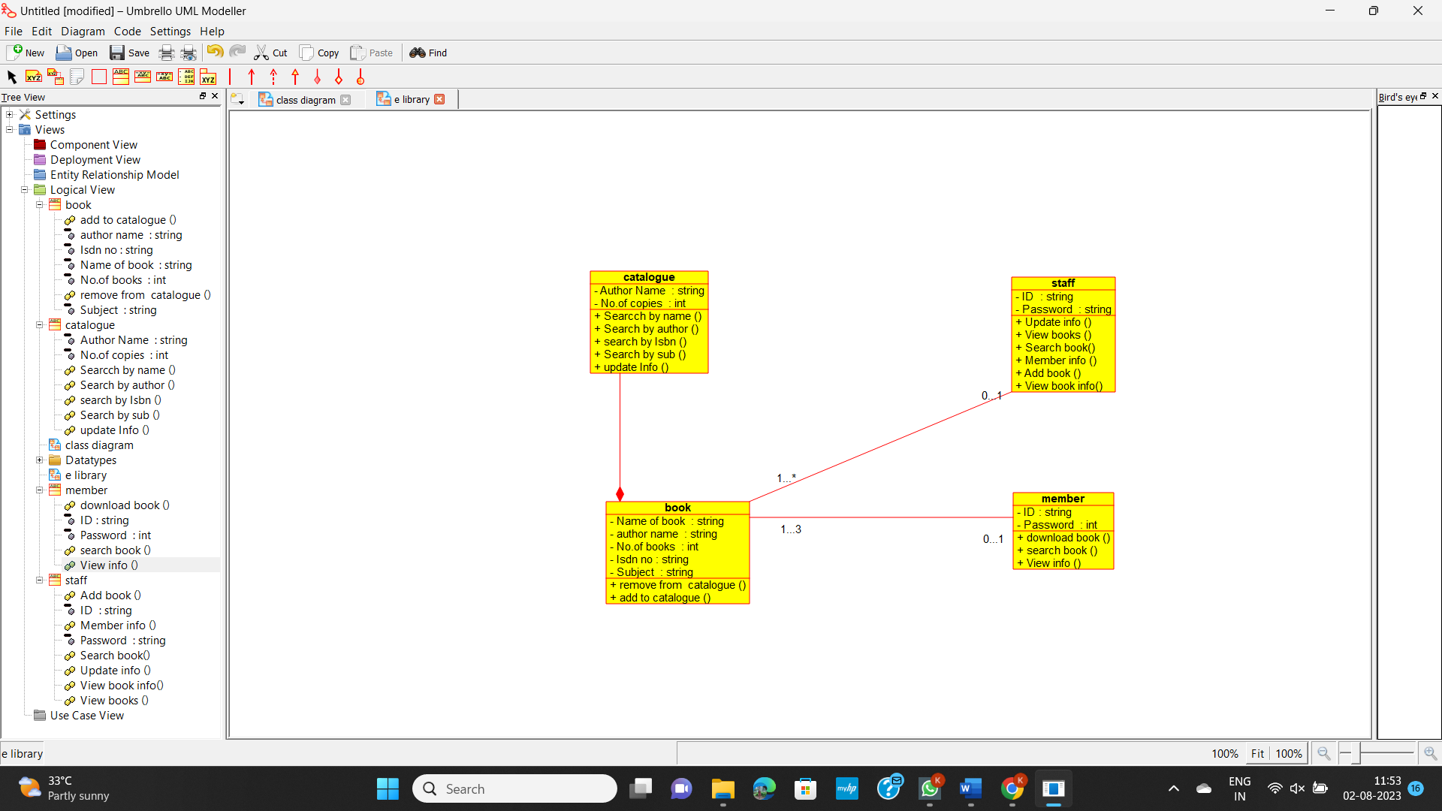

**Experiment 15:** Draw a Class diagram for a Restaurant Systems. The activities of the Restaurant system are listed below. Receive the Customer food orders, Produce the customer ordered foods, Serve the customer with their ordered foods, collect payment from Customers, Store customer payment details, Order Raw Materials for food products, Pay for Raw Materials and Pay for Labour.

